Name__________________
8th Grade
Creating a Website: Ideas

Below are a list of ideas you may choose from to create your own website. If you would like to base your site on another topic, make sure to get it approved by the teacher. Check the box of your choice or write your own idea at the bottom to be approved.

- Art website: Create a site based on your favorite artwork. This could be famous artwork, artwork of your own, or someone you know.
- Game Website: Create a site based on computer games you like to play. Put the games in categories.
- Scrap booking website: Like to scrapbook? Base your site on your work, others’ work, or ideas you find online.
- Fashion Blog: Create a site based on fashion you like. You can find ideas online. You might want to categorize your fashions by season, gender, types of clothing…
- Music Website: Love music? Create a site based on your favorite types of music, artists, and songs.
- Celebrity Site: Do you have a favorite celebrity? Base your site on that person. Include information about them such as their life journey and how they became famous.

Continue on back page
- Food website: Do you like to eat, cook or bake? Base your site on your favorite foods and recipes.
- Go Green website: Do you want to help promote saving the environment? Create a site dedicated to going green and helping save our Earth.
- Quotes Website: Do you have a bunch of favorite quotes? Make a site with all of your favorite quotes from famous people or role models.
- Holiday Website: Do you enjoy the major holidays throughout the year? Base your site on holidays like Halloween, Thanksgiving, Christmas, and Easter. Include information such as traditions, cultures, games, food and music.
- Sports website: Do you have one or more favorite sports? Base your site on that sport or sports. Include information such as favorite teams, statistics, videos, history and pictures.

- Your own idea and description

_________________________________________________

_________________________________________________

_________________________________________________

Approved by: _____________________________________________________________
Steps to Creating your Weebly Website

Username_____________________ Password________________________
Class password____________________________
- Go to: http://students.weebly.com/#login
- Sign in with your username and password that have been given to you.
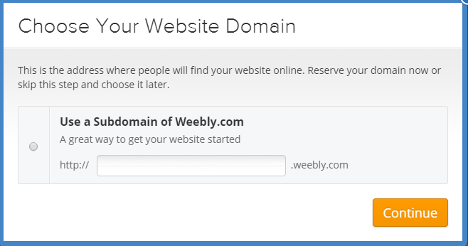
3. The picture below will display. Create a subdomain for your site, just like Ms. Shadid did (sashadid.weebly.com). After making sure it’s available, click continue. Write your domain on the rubric sheet.

- The picture below will display. Click Build my site at the bottom.
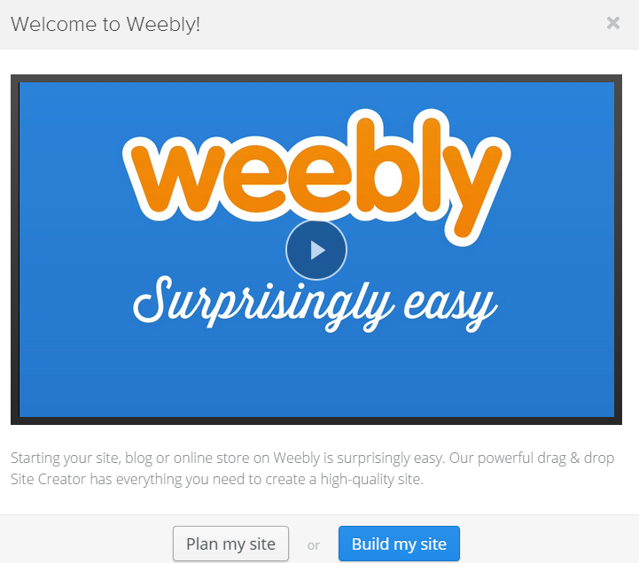

- Now you are ready to build and design your site and add pages! Follow the specific instructions each day to add different parts to your site. The requirements are listed on the back of this sheet for what needs to be included on everyone’s website.

*The Publish button below is VERY important. It is like the save button. Any time you add or make changes to your site, you must click Publish to save your work. It’s located on the top right of your screen.

Website Requirements
- At least 3 pages (Suggestion: one main home page)
- At least one title on each page
- At least one paragraph of text on each page (5 sentences)
- At least 2 images on each page
- At least one button on each page (a button acts as a link to another website)
- A theme
- Your name and topic on the top of your website

Additional Options you may want to include
- A YouTube video related to your topic
- A map related to your topic
- A “doc file” or document file you wish to share
- A survey or a poll based on your topic

Planning Sheet
Page 1
Title__________________________________________

Paragraph focus____________________________________

Image 1___________________________ Image 2_____________________________

Button link___________________________________________

Page 2
Title__________________________________________

Paragraph focus____________________________________

Image 1___________________________ Image 2_____________________________

Button link___________________________________________

Page 3
Title__________________________________________

Paragraph focus____________________________________

Image 1___________________________ Image 2_____________________________

Button link___________________________________________

Website Rubric

My domain: _______________________________________________

Element Points Possible Points Earned
Planning section is complete | 5
3 separate pages on website | 6
Each page contains a title | 9
Each page contains at least one paragraph | 30
Each page has at least 2 images | 6
Each page has at least one button link | 9
Theme, name, and topic on website | 9
Total | 74

