Name_________________________
6th Grade Excel
Notes 10 pts
Find what each of the following terms mean in Microsoft Excel:
Term Definition
Worksheet
Workbook
Formula
Function
Cell
Column
Active cell
Range
Row
Sum
Average
Max
Min
Alignment
Merge

- What is the main purpose of Microsoft Excel?

- What tab would you use to add a chart?

- Explain what each type of graph is used for:

Column
Pie
Bar
Line

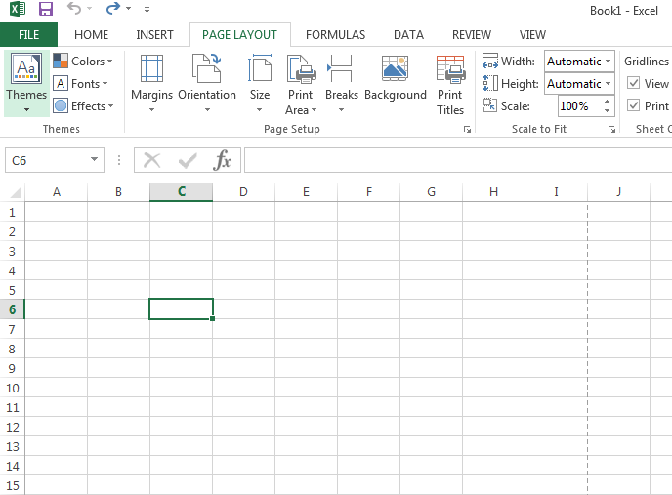
- Label: Cell, column, active cell, row

6th Grade Excel
Practice 10 pts
We will be creating a workbook in Excel of information based on car sales in the U.S. Save this as “Excel cars” to your folder.

- Open Microsoft Excel 2013- choose blank workbook.
- Add one more sheet to your workbook. (Click the plus sign at the bottom of the screen)
- Rename the sheets at the bottom to “August 2013”, and “August 2014”. Each sheet represents cars that were sold in the month of August 2013, and 2014
- On the first sheet (August 2013), create a title in cell A1: “Car Sales for 2013”
- In cell A3, create a title “Type of Car” and in cell B3 crate a title “Number of Cars Sold”
- Bold the text in cells A1, A3, and B3. Merge and center the text in cell A1, and make the font size 20.
- In cells A4 through A10, type the following list of cars:
- Honda
- Toyota
- Nissan
- Jeep
- Ford
- BMW
- Mercedes

- In cells B4 through B10, type the following amounts:
- 38,000
- 35,800
- 26,300
- 14,000
- 38,700
- 19,300
- 21,800

- Format cells B4 through B10 to include a comma, but no decimal.

10. In cell A12, type “Total Cars Sold” and bold the text
11. Adjust the column widths to see all information in each column, if necessary.
12. Use the SUM function in cell B12 to total the number of cars sold.
13. Adjust the column widths.
14. Type your first and last name in cell A16.

15. On the second sheet (August 2014), create a title in cell A1: “Car Sales for 2014”

16. In cell A3, create a title “Type of Car” and in cell B3 crate a title “Number of Cars Sold”

17. Bold the text in cells A1, A3, and B3. Merge and center the text in cell A1, and make the font size 20.

18. In cells A4 through A10, type the following list of cars:
- Honda
- Toyota
- Nissan
- Jeep
- Ford
- BMW
- Mercedes

19. In cells B4 through B10, type the following amounts:
- 26,000
- 32,000
- 41,000
- 34,000
- 39,000
- 18,000
- 17,000

20. Format cells B4 through B10 to include a comma, but no decimal.

21. In cell A12, type “Total Cars Sold” and bold the text

22. Adjust the column widths to see all information in each column, if necessary.

23. Use the SUM function in cell B12 to total the number of cars sold.
24. Adjust the column widths.
25. Type your first and last name in cell A16

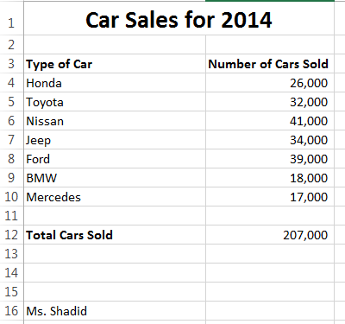
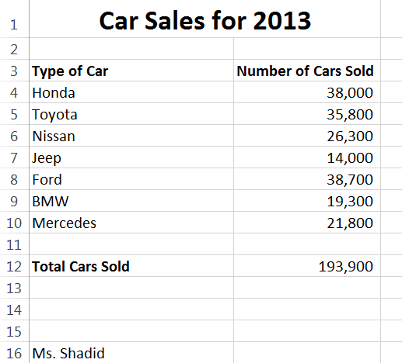

6th Grade Excel
M&M Distribution Project 20 pts

Overview
You will be predicting, recording, and reflecting on information based on how M&M candies are distributed by color.

Step One- 5 pts
- Type a one paragraph prediction on how you think the M&Ms colors will be distributed. Do you think there will be more of one color than all the other colors? Do you think you will be missing a color all together?

- Record all the group M&M color information on your chart. We will do this step together as a class. You will write how many of each color each group has.

Step Two- 5 pts
You will create a spreadsheet on Excel, and enter your chart data, then save your work.

Step Three- 5 pts
You will create a graph in Excel based on your spreadsheet data.

Step Four- 5 pts
Type a one paragraph reflection, assemble all your project information, staple and turn in.

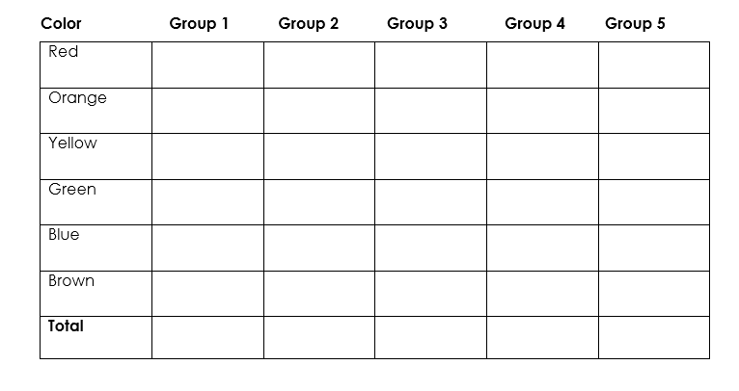

Excel Packet Rubric

Element Points Possible Points Earned
Notes | 10
Practice | 10
M&M – step 1 | 5
M&M- step 2 | 5
M&M- step 3 | 5
M&M- step 4 | 5
Total | 40

