Name_____________________________

8th Grade
Microsoft Excel

Practice: Creating a spreadsheet based on MLB ticket sales …10 points

Project: Creating a spreadsheet and report about fast food nutritional information … 40 points

50 points total

8th Grade Excel
Practice 10 pts

We will be creating a workbook in Excel of information based on ticket sales in the U.S. Save this as “Excel tickets” to your folder.

- Open Microsoft Excel 2013- choose blank workbook.
- Add one more sheet to your workbook. (Click the plus sign at the bottom of the screen)
- Rename the sheets at the bottom to “August 2013”, and “August 2014”. Each sheet represents baseball tickets that were sold in the month of August 2013, and 2014
- On the first sheet (August 2013), create a title in cell A1: “Ticket Sales for 2013”
- In cell A3, create a title “Team” and in cell B3 create a title “Number of Tickets Sold”
- Bold the text in cells A1, A3, and B3. Merge and center the text in cell A1, and make the font size 20.
- In cells A4 through A10, type the following list of teams:
- New York Yankees
- Atlanta Braves
- Chicago White Sox
- Cincinnati Reds
- Houston Astros
- Minnesota Twins
- St. Louis Cardinals

- In cells B4 through B10, type the following amounts:
- 240,000
- 350,800
- 225,300
- 210,000
- 315,700
- 260,300
- 235,800

- Format cells B4 through B10 to include a comma, but no decimal.

10. In cell A12, type “Total Tickets Sold” and bold the text
11. Adjust the column widths to see all information in each column, if necessary.
12. Use the SUM function in cell B12 to total the number of tickets sold.
13. In cell A14, type “Average Amount Sold per Team”, bold the text
14. In cell B14, use the AVERAGE function to find the average number of tickets sold
15. Adjust the column widths.
16. In cell A16, type “Maximum tickets sold”, bold the text
17. In cell B16, use the MAX function to find the maximum number of tickets sold
18. In cell A18, type “Minimum tickets sold”, bold the text
19. In cell B18, use the MIN function to find the minimum number of tickets sold
20. Type your first and last name in cell A20.

21. On the second sheet (August 2014), create a title in cell A1: “Ticket Sales for 2014”

22. In cell A3, create a title “Team” and in cell B3 create a title “Number of Tickets Sold”

23. Bold the text in cells A1, A3, and B3. Merge and center the text in cell A1, and make the font size 20.

24. In cells A4 through A10, type the following list of teams:
- New York Yankees
- Atlanta Braves
- Chicago White Sox
- Cincinnati Reds
- Houston Astros
- Minnesota Twins
- St. Louis Cardinals

25. In cells B4 through B10, type the following amounts:
- 260,000
- 320,000
- 223,000
- 195,000
- 270,000
- 300,000
- 170,000

26. Format cells B4 through B10 to include a comma, but no decimal.

27. In cell A12, type “Total Tickets Sold” and bold the text

28. Adjust the column widths to see all information in each column, if necessary.

29. Use the SUM function in cell B12 to total the number of tickets sold.
30. In cell A14, type “Average Amount Sold per Team”, bold the text
31. In cell B14, use the AVERAGE function to find the average number of tickets sold
32. In cell A16, type “Maximum tickets sold”, bold the text
33. In cell B16, use the MAX function to find the maximum number of tickets sold
34. In cell A18, type “Minimum tickets sold”, bold the text
35. In cell B18, use the MIN function to find the minimum number of tickets sold
36. Adjust the column widths.
37. Type your first and last name in cell A20

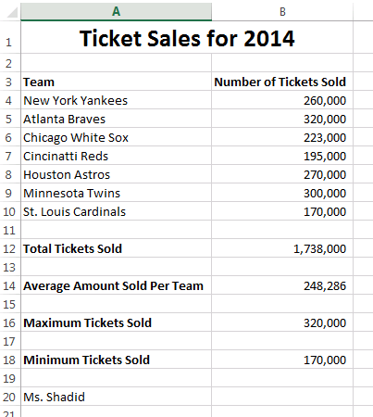
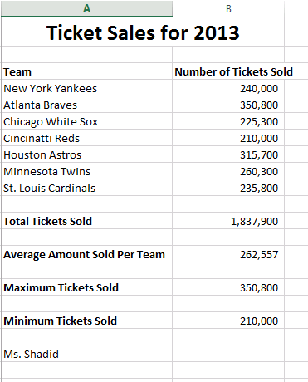

Fast Food Project

Overview

You will be researching, recording, and reflecting on fast food information. You’ll choose a fast food restaurant and 4 food items from their menu.

Step One:
Decide which fast food restaurant you would like to visit. Some examples are below.
McDonald's: http://www.mcdonalds.com/app_controller.nutrition.index1.html
Burger King: http://www.bk.com/
Other Restaurants: http://www.nutritiondata.com/ (Type in your fast food restaurant at the top where you see “enter food name”. (Leave the second search box as “All food categories”) Example: subway
My restaurant_________________________________
Plan a meal including four items: a sandwich, salad or other main dish, a side dish (French fries, etc.), a drink, and a dessert. For each item on your menu, record the calories and the calories from fat.

Step Two:
Enter your data in the table below. Then compare your information with another student. After recording your food information, record information about which restaurant they visited, what food they ate, and the nutritional content of that food.

You may need to know: There are 9 calories in 1 gram of fat.
Your information
Food Item | Calories | Fat Calories
Main dish:
Side dish:
Drink:
Dessert:

Other student’s information
Their restaurant_________________________________
Food Item | Calories | Fat Calories
Main dish:
Side dish:
Drink:
Dessert:

Step Three
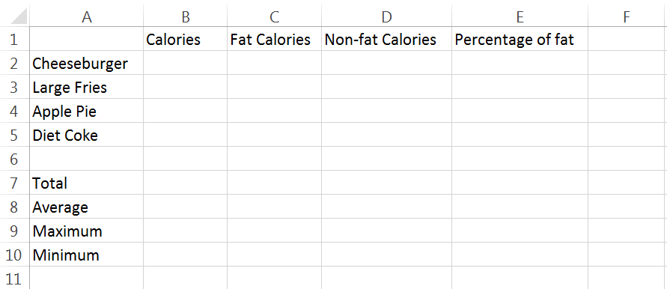
Entering Data and Formulas:
Set up your Excel spreadsheet like the one above, using your own food item choices. You will enter the calories in column B and fat calories in column C.
To figure out non-fat calories, write a formula to subtract the fat calories from the total calories. (HINT: =B2-C2)
To figure out the percentage of fat, divide fat calories by calories. Format the cells in column E for percentage. (HINT: =C2/B2)
To figure out total calories, total fat calories, and total non-fat calories, use the Sum function. To figure out the total percentage of fat, divide total calories by total fat calories.
To find the averages, use the AVERAGVE function
To find the maximums, use the MAX function, and to find the minimums, use the MIN function.

Step Four:
Using Microsoft Word, type a two paragraph report about this project. Include at least 5 sentences in each paragraph.
Paragraph #1: Introduction including which restaurant you chose and why. Explain the 4 food items you chose from their menu. Did you choose these food items because you like them, they are healthy, or you wanted to try something new? Also explain how you used Excel to organize and display your nutritional information.
Paragraph #2: Summarize the information about your meal including number of calories, percentage of fat, etc. Copy and paste your chart (from Excel) into your document as supporting evidence. Use the information you found to evaluate your meal. How does your percentage of fat compare to the percentage of daily fat recommended? (You will need to look up this amount) Have you planned a healthy meal? What changes might you make in your meal to make it healthier?
When you finish the report, save and print it, attach it to your other handouts and put the whole packet in the 8th grade basket. Make sure your name is on it!!

8th Grade Excel Rubric
Excel Practice: Print out your 2 spreadsheets | 10
Step 1: Chosen fast food restaurant | 5
Step 2: Data filled out in chart & completed other student information | 15
Step 3: Complete and correct Excel spreadsheet (print out) | 10
Step 4: Complete 2 paragraph report (print out) | 10
Total | 50
Element Points Possible Points Earned

