Name____________________________

**Copy and Paste Living and Non-Living Things**

**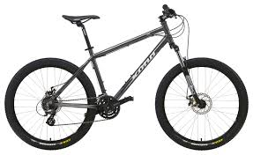****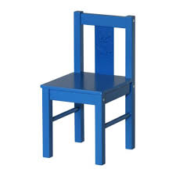**

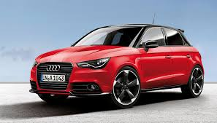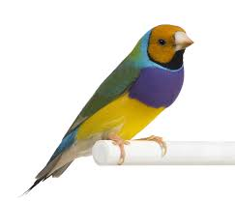

|  |  |
| --- | --- |
| **Living** | **Non-Living** |
|  |  |
|  |  |
|  |  |