A | Active cell, application, avatar, address bar
B | Bcc, bit, browser, blog
C | Caps lock, cell, clip art, cloud
D | Domain, desktop, download, Dvorak keyboard
E | Email, e-commerce, e-book, Excel
F | Flash drive, file, floppy disk, font
G | Google, Gigabyte, graphics
H | Hard drive, hardware, hash tag, hyperlink
I | Internet, input device, intellectual property, inbox
J | Jpeg, java, joystick
K | Keyboard, keywords, kilobyte
L | Laptop, left-click, link, log on
M | Mouse, malware, memory, modem
6th Grade
Computer ABC Presentation Name(s) _________________

You’ll create a PowerPoint presentation alone or with a partner of computer words that start with each letter of the alphabet. You’ll have two letters on each slide and a title slide at the beginning for a total of 14 slides. Circle, underline or highlight your word choice for each letter below. You’ll need a description or definition and a picture for each in your presentation. 50 Points

N | Network, navigation bar, netiquette
O | Online, Office, output
P | Printer, password, paste, processor
Q | Qwerty, QR code, Queue
R | Restart, router, restore, refresh
S | Scroll bar, server, software, status bar
T | Tool bar, table, template, text box
U | USB, undo, upload, username
V | Virus, variable, volume
W | Website, web design, webcam, word processor
X | XP, XML
Y | YouTube, Yahoo
Z | Zip file, zettabyte

Save your presentation as “first and last name’s Computer ABC’s” to your public share folder.
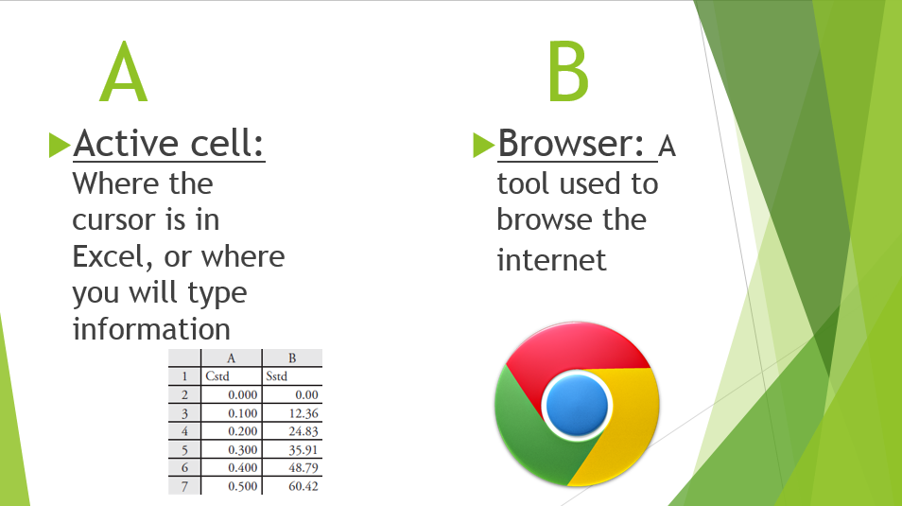
Sample slide

Project Rubric
Element Points Possible Points Earned
Presentation contains all 26 letters of the alphabet and one computer related word for each letter | 13
Contains a description for each word | 13
Contains a picture for each word | 13
Contains a title with your name(s ) | 2
Presentation is easy to hear, clear, and presenter(s) does not block the screen | 4
Work is divided evenly if you have a partner | 5
Total | 50

