8th Grade Microsoft Word Name______________________
Word Notes: Answer each of the following questions. 12 pts.

- What tab and group do we use for most of the text formatting?

- What tab do we use for clipart and pictures?

- What is the difference between online pictures and pictures?

- What tab do we use to create a table?

- What are some examples of when we would use a table?

- How can you adjust the size of a table?

- What tab do we use to create shapes?

- Name 3 examples of shapes you could see yourself commonly using:

- What tab do we use to create a hyperlink?

- What is a hyperlink?

- What are shortcut keys? Give 5 most commonly used shortcuts:

- What do we use the page layout tab for?

Word Practice: Type each of the following in a Microsoft Word document, labeling each with the corresponding letter and number. Save the document as “Word practice” to your folder.
- Type a numbered list of your top 10 favorite restaurants/ fast food places to eat in Bloomington/ Normal, 1 being your most favorite. Make the following changes to your list: 5 pts.

- Italicize
- Change the font
- Underline
- Bold
- Make the font a different color
- Center align the text
- Strikethrough the text
- Highlight the text
- Change the font
- Double underline

- Find a clipart picture for each of the following: 5 pts.
- Baby
- Coffee
- Basketball
- Tree
- Shirt
- Dog
- Fork

- Pizza
- Teacher
- Television

- Create a table of your daily school schedule. Have at least 2 columns. 5 pts.

- Create a picture or scene using at least 10 shapes in Word. 5 pts.

- Create 5 hyperlinks to the websites of your choice. 5 pts.

Word Notes and Practice Rubric

Element Points Possible Points Earned
Notes | 12
Practice A | 5
Practice B | 5
Practice C | 5
Practice D | 5
Practice E | 5
TOTAL | 37

8th Grade Communication
Letters, Memos, Email
Notes and Practice

Letters: Notes 12 pts.
1. What is a letter?

2. Who does a letter communicate with?

3. Why might a letter be sent to someone inside a company, instead of an email or memo?

4. What is block style?

5. What is the very first line of the entire letter?

6. Give an example of a title before someone’s name.

7. What is a salutation?

8. What is a closing?

9. What goes directly below the closing?

10. What would the initials represent, below the senders typed name?

11. What are enclosures?

Additional tips for writing business letters:
*

*

*

*

*

*

*
Letters: Practice 10 pts.
a. Practice writing a business letter by hand. Use today’s date. The recipient is Mr. John Smith. The street address is 241 South Street Chicago, IL 60934. You are writing to ask Mr. Smith about how your company’s customer service is doing. Make sure to format the letter properly. Write at least 3 sentences. You may want to refer to the example on page 7 for formatting.

b. Find a classmate to peer review your written letter above. They should write suggestions and make changes to help make your letter its best.

c. Type the letter you prepared with the changes that have been suggested. Save the typed letter to your class folder.
Example of a Letter: Block style
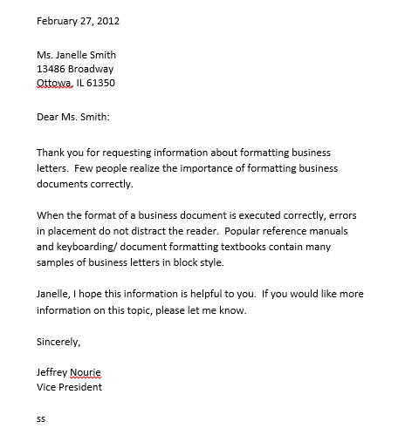

Memos: Notes 7 pts.
- What is a memo?

- What is a memo used for?

- What are the five headings for a memo?

- How should a memo be aligned?

- How should a memo’s heading be formatted?

- What are some things to consider when writing a memo?

- What if someone else is receiving a copy of the memo?

Memos: Practice 5 pts.
- Practice writing a memo in the space below.
- You are writing to a co-worker named Matt Johnson
- The date is today’s date
- The subject is “Meeting”
- Jane Morris is receiving a copy of the memo

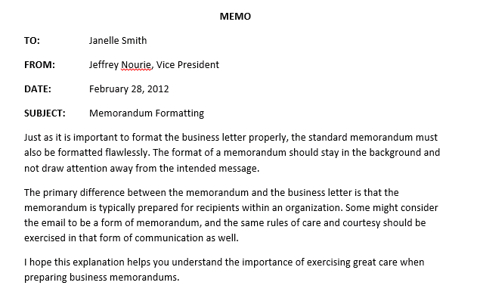
Example of a Memo:

Email: Notes 5 pts.
- What is email and what are some benefits of using it?

- Who does email communicate with?

- What format is an email similar to?

- What does Bcc and Cc mean?

- What should go in the subject line?

This email is about the interview scheduled for next week at 1:00
I can’t make it to my interview. I’M TOO BUSY!
Sorry i wont be able to make it on time.

Email: Practice 10 pts.
- What is wrong with the email above? List all of the issues below.

Letter notes | 12
Letter practice | 10
Memo notes | 7
Memo practice | 5
Email notes | 5
Email practice | 10
TOTAL | 49

Communication Notes and Practice Rubric

Element Points Possible Points Earned

8th Grade Word and Communication
Quiz Review

Quiz format: Multiple choice/ short answer

Know these topics:

- What the insert tab is used for- Word
- What hyperlinks are- Word
- What the page layout tab is used for- Word
- Examples of shapes you can insert- Word
- Purpose of business letters- Communication
- Purpose of an email subject line- Communication
- First line of a business letter- Communication
- Block style- Communication
- Difference between business letter and business memo- Communication
- BCC and CC- what are they used for?- Communication

